Hughes, Plath & Birthday Letters – context, issues and representation
The following definition of autobiographical writing is useful for this study:
Autobiographical writing is…a narrative account written by an individual that purports to depict his or her life and character. Unlike diaries and journals which are kept for the author’s private use, autobiographies are written expressly for an audience. Autobiographies are distinguished from memoirs (also produced for public consumption), whose authors render an account of the people and events they have known and experienced without providing the detailed reflection and introspection characteristic of most autobiographies.
Murfin, R. The Bedford Glossary of Critical and Literary Terms. p 28 Bedford Books. Boston 1998
Memory is unreliable. Hughes may have chosen to conceal or re-interpret events and situations that were potentially unflattering or damaging to others including him and the children of his marriage to Plath. Whereas diaries or journals are often not intended for publication, Birthday Letters written after a long silence and towards the end of his own life can be seen as Hughes’ attempt to vindicate himself against critics who condemned him for Path’s suicide.
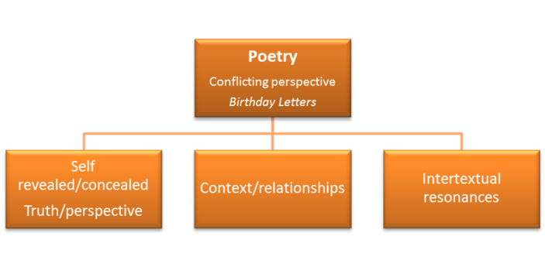
Conflicting Perspectives – Birthday Letters & Ted Hughes
•Concern for ‘truth telling’
•Memory – insight into past, influence of past
•Place
•Revelation and concealment – no life can be fully recounted
•Context – historical, political and cultural
•Mixture of fact and fiction
•Voice – sense of person, point of view
•Allusions to culture, history, art and literature
•Writing and reflection to understand connections between past, present and future
•Relationships – insight into connections between past, present and future
•Conflict between cultures and values– conservative English valuing of restraint and duty and more demonstrative American valuing of enthusiasm and emotion.
•Freedom and patriarchal society, role of woman restricted to wife and mother, growing influence of feminism.
•Privileged ideas and perspectives – creative imagination, poetry, self-knowledge, power play, influence of the past on the present, Hughes as victim
•Symbolic use of imagery – red/blood, white/ death, blue/gentleness, mythology, weapons, animals

Context

Ted Hughes
Hughes was acclaimed in as a writer of stature during his life and was awarded the Poet Laureate in 1984. He was not generally considered as a confessional poet despite his intimate, personal accounts of his relationship with Plath and the affect her mental illness had on their relationship. His early body of work focused on nature and was informed to some extent by the values of Romanticism although his view of nature focused on the savagery and vitality of nature rather than its beauty. Published in 1998 in the same year as his death, Birthday Letters primarily focused on his relationship with Plath and differs from his previous work although it still reflects his historical and literary context. Hughes’ view of his political and historical context is influenced by the trauma of WW11 and British politics.
Unlike Modernist poets such as T.S Eliot, Hughes sometimes focussed on confrontational honesty in his reflections on his relationship with Plath. This inevitably reflected the modern condition. Birthday Letters, a product of Hughes’ later style, has a colloquial quality and intimacy rather than his earlier detached style seen in his nature poems such as Death of Pig and Hawk Roosting. In these he focused on natural phenomena to provide insights into human behaviour by reflecting on humans as animals. Hughes achieves the effect of honesty through skilful manipulation of images, rhythms, inclusions, omissions, concealments and arguably fictions.
Hughes does not identify with the spiritual aspects of Nature, like Romantic poets such as Coleridge or Keats, but with nature’s sensuality and savagery. This is reflected in his detached and sometimes brutally honest style including detailed observation of violence. Hughes’ honesty is called into question in Birthday Letters for several reasons: the poems were published after the lapse of thirty five years and when read in conjunction with Plath’s own poems, letters and diaries differ markedly from her perspective. This is true of Plath’s Whiteness I remember and Hughes’ Sam both describing the same event. Hughes’ perspective however is based on Plath’s own account of an incident which Hughes did not witness.
Plath’s Ariel and Daddy also provide interesting insights into her perspective of her relationship with Otto Plath, her dead father which Hughes cites in The Shot, Minotaur and elsewhere as the cause of her mental instability and the insurmountable barrier in their marriage. Anne Whitehead’s comments are useful for the insights they provide into Hughes and Plath’s relationship. (Refiguring Orpheus: the possession of the past in Ted Hughes’ Birthday Letters. Routledge 1999)
Similarly, critics such as Lydia K. Bundtzen in Mourning Eurydice: Ted Hughes as Orpheus in Birthday Letters evaluate the controversy caused by Hughes’ publication of Birthday Letters and the body of work that accused Hughes of undue censorship and bias in his treatment of Plath’s estate, specifically her letters, diaries and journals written after their divorce. These critics argue that Hughes suppressed texts that represented him critically and which could be interpreted as blaming his infidelity, abandonment of Plath and their children and marriage to Assia Wevill as leading eventually to Plath’s suicide in 1963.
It is important for this study to remember that both perspectives must be evaluated:
- Plath as a gifted by deeply troubled and mentally unstable woman whose inability to free herself from the past prevented her from enjoying a productive and stable relationship with Hughes.
And/or
- Plath as a gifted poet and the victim of Hughes’s serial infidelities and indifference. It is to discredit this view that it is argued Hughes wrote Birthday Letters.
